Pre - Solo Exam

Student Name____________________________________________________

Date____________________________________________________________

Flight Instructor__________________________________________________

Planned Solo Date________________________________________________

This exam is take home and open book. Prior to student solo, the instructor will discuss both incorrect and correct answers to validate the student have complete understanding of the information being tested in this test. The student MUST solo within 2 weeks of taking the test; otherwise it is not valid for solo.

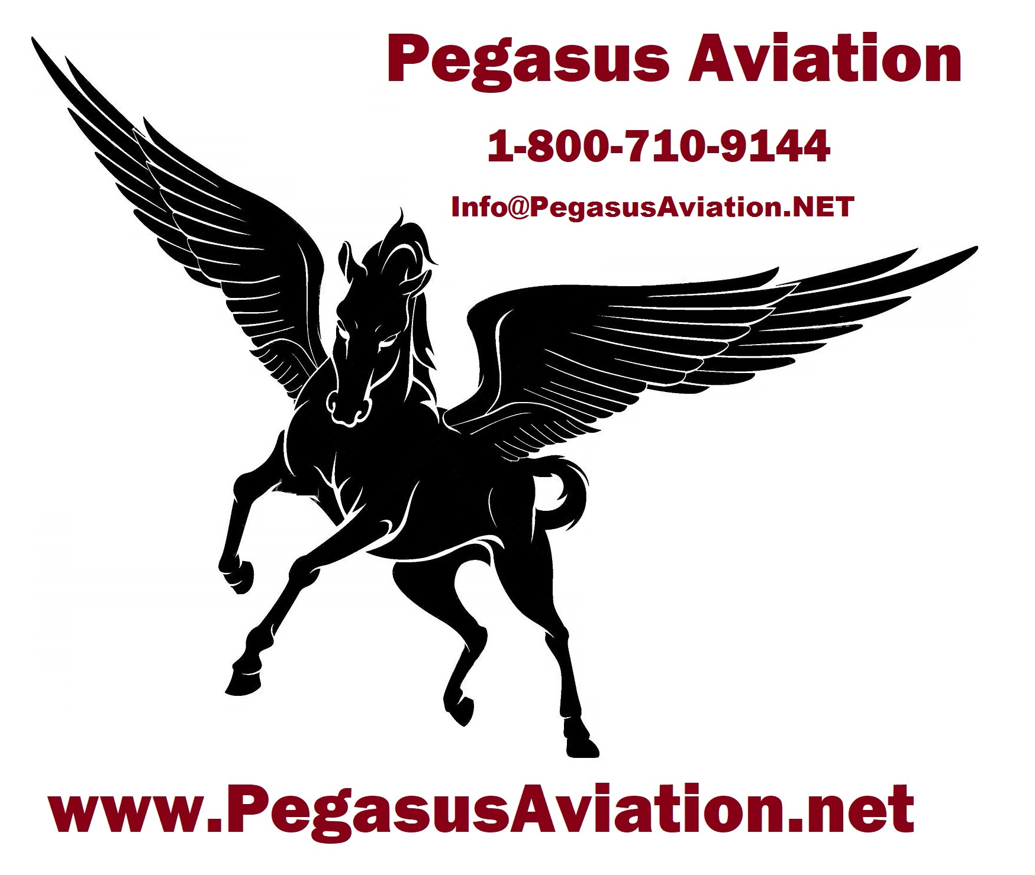
1. What type of engine does the N9637Q have?

2. What is the engine horsepower?

3. How many gallons of useful fuel does this aircraft hold?

4. What type of oil should be used in this engine?

5. Please define:

Vx

Vy

Vg

Vne

Vno

Va

Vfe

Vs1

Vso

6. What is the maximum demonstrated crosswind component for the aircraft?

7. How do you adjust the pitch trim with the electric pitch trim switch?

8. How do you adjust the pitch trim with the manual trim wheel?

9. Can how do you override the electric pitch trim?
10. What are the ways to disconnect the electric pitch trim and what is the order of disconnecting it?

11. How do you set visually trim for take off without using the marking on the manual wheel?

12. Describe the loss of engine procedures for the aircraft.

13. What is the maximum gross weight of the aircraft?

14. What is the empty weight of the aircraft?

15. What is the useful load of the aircraft?

16. With full fuel, how much weight can you carry in the aircraft?

17. What preflight actions are required before a flight not in the vicinity of an
airport?

18. List the minimum equipment and instruments that must be working properly in your aircraft for flight.

19. How many hours are required between consuming alcohol and flying?

20. What is the maximum blood alcohol content to legally operate an aircraft?

21. What are the weather minimums, as defined on your solo endorsement?

22. What altitude should you fly when operating in level cruising flight at more than 3,000 feet agl?

23. What type and grade of fuel is used in the aircraft?

24. How do you check the oil level in the aircraft?

25. What is the maximum allowable flap setting for takeoff in the aircraft?

26. What documents and endorsements are you required having in your possession to legally operate the airplane as a student pilot?

27. Do you need your logbook in your possession when you fly solo? Why/Why not?

28. Draw a runway and a traffic pattern and label each leg.

29. Describe in your own words how to perform a proper GO AROUND

30. Which turn direction is standard for a traffic pattern?

31. When do we at KCVO not have a standard traffic pattern, and were do you go to find the information stating the pattern has changed direction?

32. How do you enter and exit the traffic pattern at an uncontrolled airport?

33. Describe “Wake turbulence”.

34. In which type of aircraft and in which configuration is this most prominent?

35. What is proper procedure to avoid wake turbulence?

36. When are you required to wear a safety belt? Shoulder harness?

37. What must a pilot do before entering Class D airspace?

38. What is the minimum altitude you can fly anywhere?

39. Over congested areas?

40. Over other than congested areas?

41. Over sparsely populated areas or open water?

42. List the documents that must be aboard the aircraft at all times

43. Who has the final authority and responsibility for the operation of the aircraft when you are flying solo?

44. Can you operate in Class B airspace as a student pilot?

45. What is the minimum fuel requirement for VFR day conditions? What are your personal minimums? What is the policy for Pegasus aircraft to dispatch?

46. If the altimeter setting is not available at an airport, what setting should you use before departing on a local flight?

47. What are the limitations of a student pilot, as stated in Part 61.89 of the Federal Aviation Regulations?

48. Give three situations that would necessitate a go-around.

49. What are the ways and in what order do you disconnect the autopilot?
1. ________________

2. ________________

3. ________________

4. ________________

5. ________________

50. Draw correct traffic patterns and list the direction of wind for each runway.
(no greater than 10 knots and no cross winds)

RWY 17 winds _________

RWY 35 winds _________

RWY 10 winds _________

RWY 28 winds _________

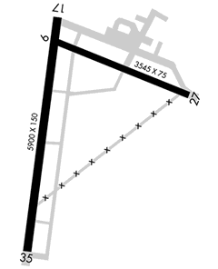

Student Signature______________________________________

Instructor Signature______________________________

Date of Review/Logbook Endorsement____________________________

